**a. Title Page:**

Hadia Majed

BCS 360

Professor Lees

CRN: 94518

**Ulta Online Shopping System:**





**b. Overview of the Company:**

* **Company Name:** Ulta
* More than thirty years ago, we redefined the beauty retail experience by bringing all things beauty into one place. Today, Ulta Beauty is one of the largest beauty retailers in the U.S. providing beauty lovers with cosmetics, fragrances, skincare products, hair care products, and salon services. These are all the foundational aspects of our business model to ensure Ulta Beauty remains competitively differentiated and appealing to the guests.

You’ll have a great shopping experience because we meet guests where they are to help them discover their beauty favorites and meet their beauty needs across our retail locations, website, and mobile applications. We offer over 25,000 products from more than 600 established and up-and-coming brands, including the Ulta Beauty Collection, which is our private label. In addition to these beauty products, we also operate a salon in every store, providing guests with a wide range of many beauty services that they could choose from.

The guests can shop for their beauty needs at our stores, online at ulta.com, and even through our mobile applications. For some added convenience, we also offer a variety of fulfillment options including buying online and pickup in-store, buying online and picking up curbside, shipping from the store, and shipping to home.

* 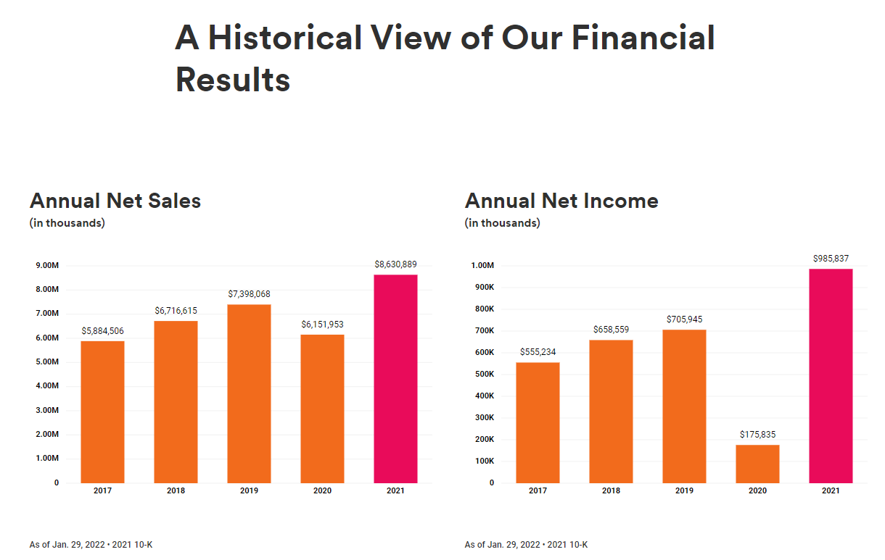 For my project, the **single operation will be an online shopping system** which is a type of electronic commerce that allows customers to buy goods or services over the Internet and it is done via a web browser or using a mobile app to do so. This is what I am going to use to create my database to meet its operational needs

**c. Requirements identified:**

* **Shopping Management:**  It saves the customer’s shopping information and it also serves as the admin’s basis for the order of the customer.
* **Customer Management:** This gathers important information about the customers and then the gathered information was then used to determine the customer’s orders and transactions.
* **Manage Transactions:** This allows the admin to monitor the transactions made by the customers. It saves all the transactions done as well as the shopping information of that individual.
* **Transactions and Reports Management:** This stores the transactions that are made by the customers. It also includes information and also reports of every transaction.
* The issues that this will solve are that when a shopper buys something or puts in an order, the system should store information about them.
* The users can effectively use this to complete specific tasks by placing their order online and then whatever information that the customer entered is going to be saved and will be made as a transaction process which will then complete their order and will provide them a transaction report.

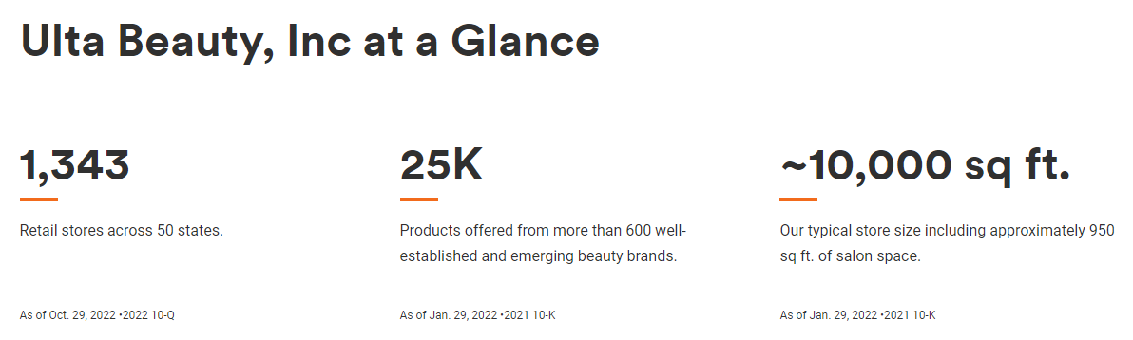

**d. E-R Model:**

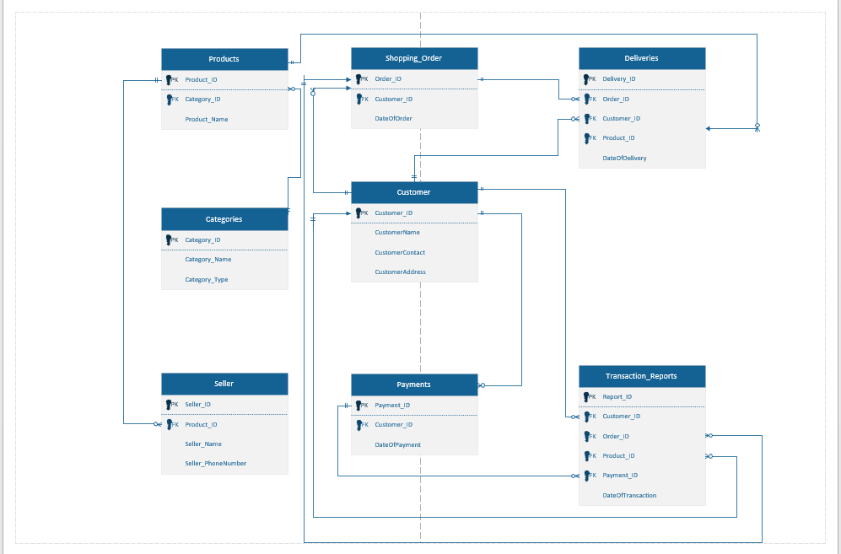

**e. Database Implementation – include all logic used to create the database. Include screenshots of all tables created and data loaded:**

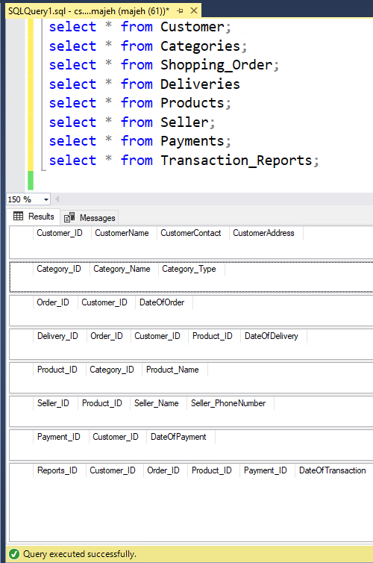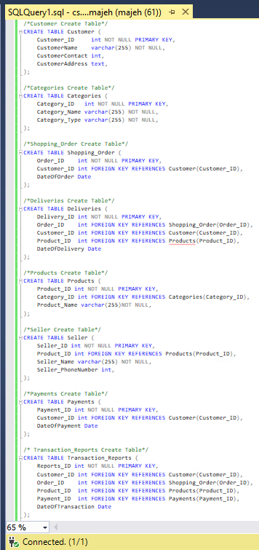

**e. Database Implementation – include all logic used to create the database. Include screenshots of all tables created and data loaded:**

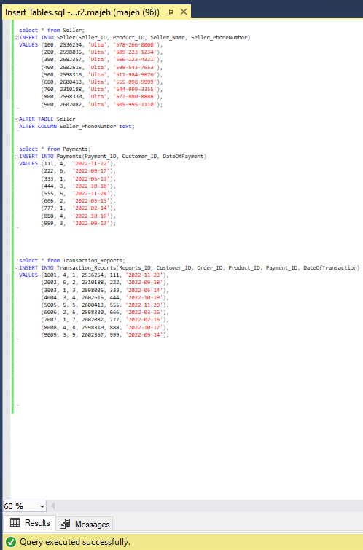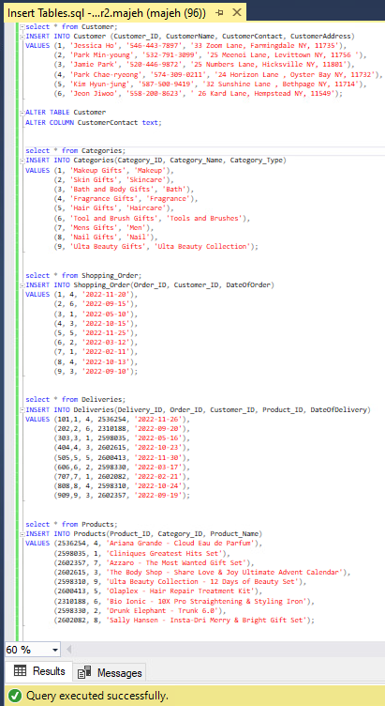**(Screenshot of Insert tables)**

**e. continued - (Insert of Insert Tables with data loaded):**

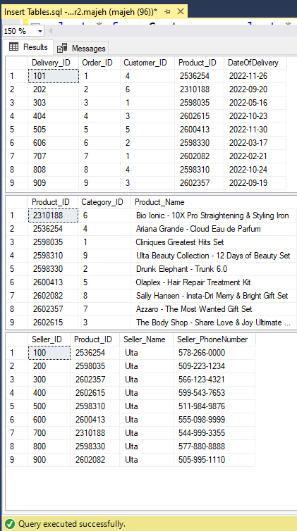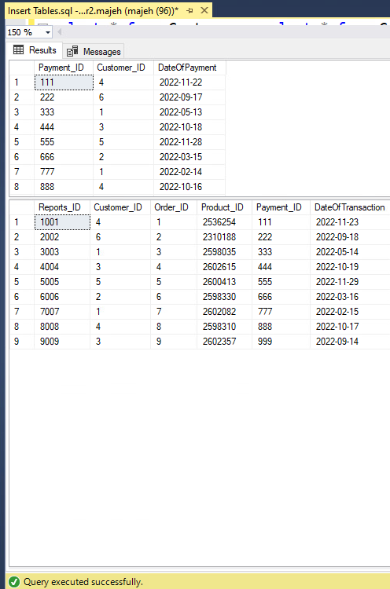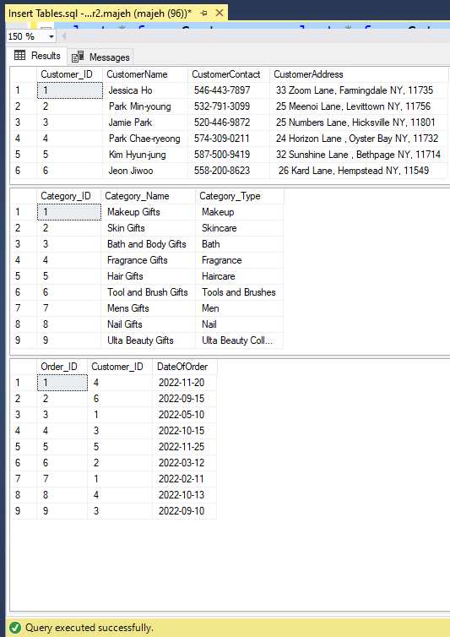

**f. Test Cases:**

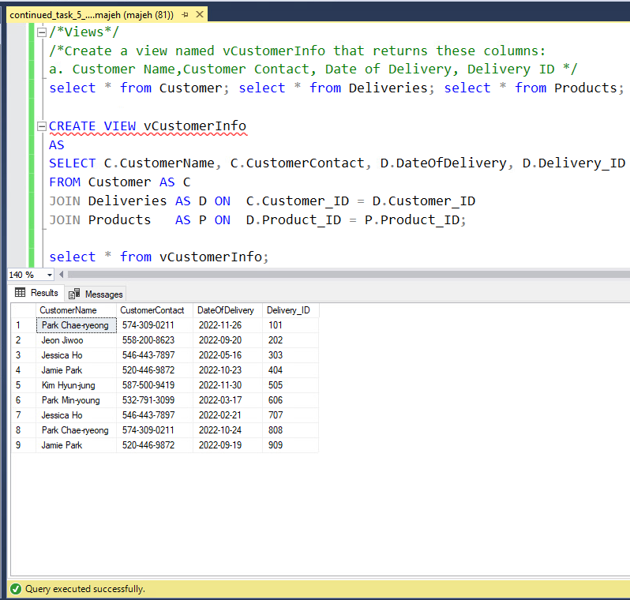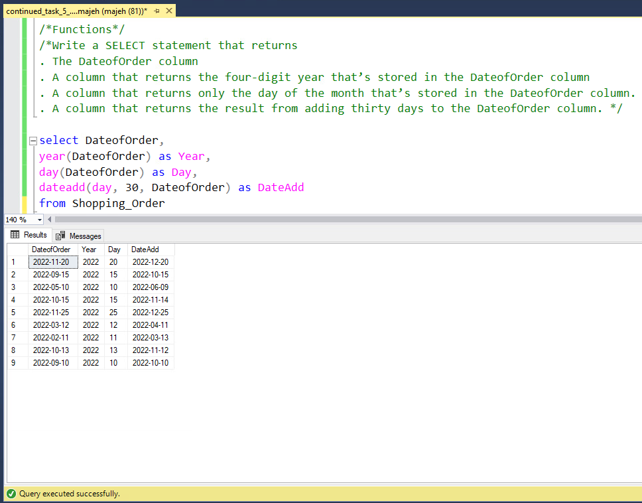

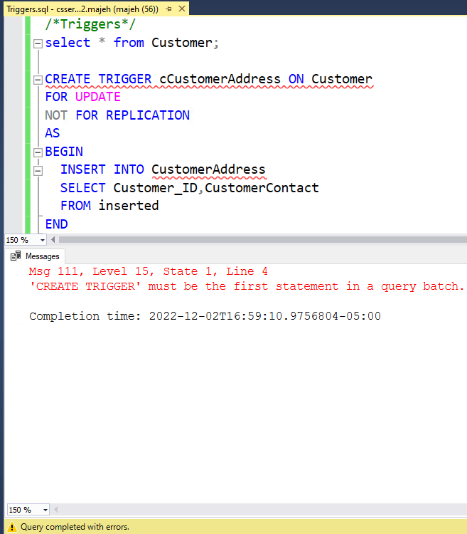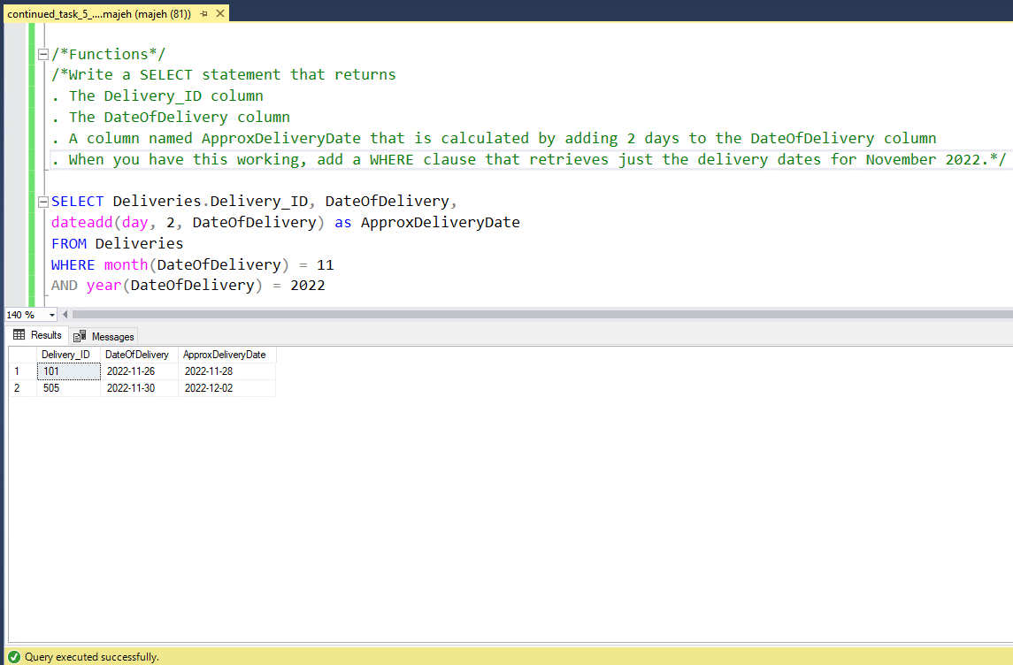

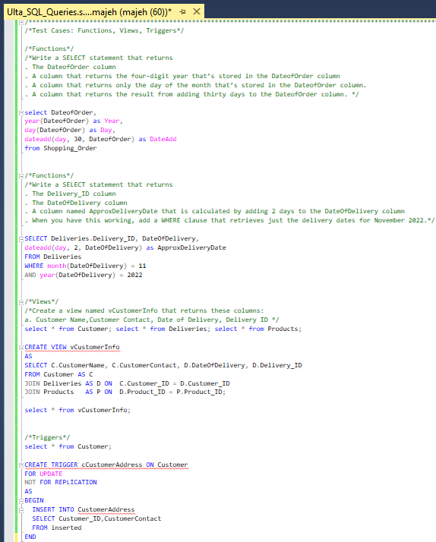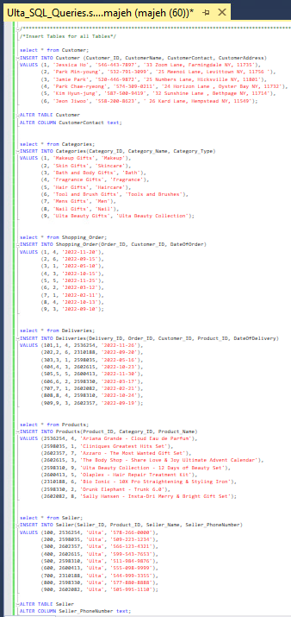**g. Solution Design (Screenshots acceptable):**

